Ideation Phase Empathize & Discover

Date | 4 September 2026
Team ID | Individual
Name | Namburi Sriya Ram
Project Name | Employee Raise Issue – Record Producer & Service Portal Integration
Maximum Marks | 4 Marks

Empathy Map:

User: Employee requesting licensed software through the ServiceNow Service Catalog
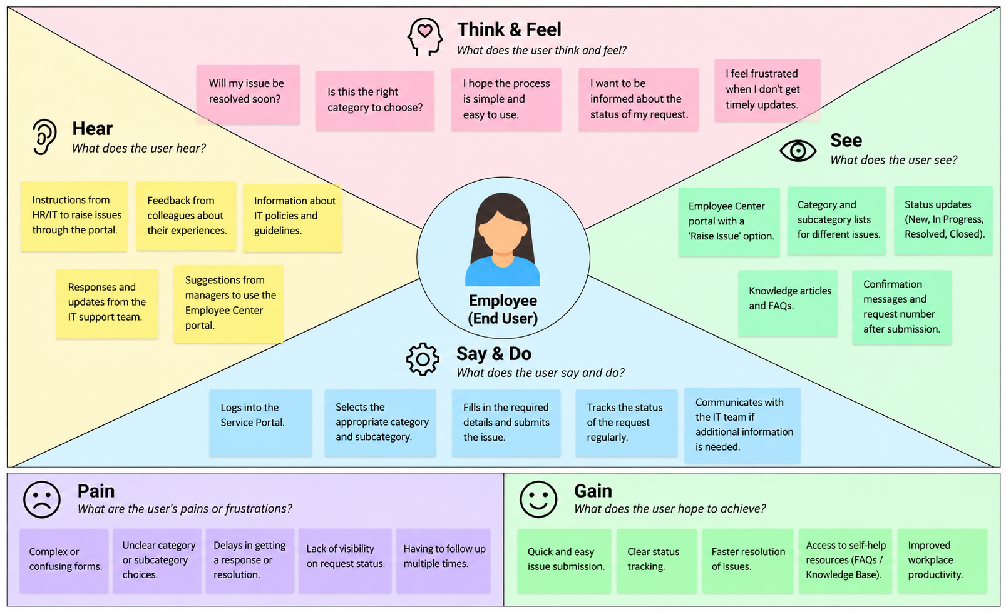

Key User Insight
The employee wants a quick and transparent way to request licensed software, with clear approval status and timely IT fulfillment.

